Title: Tour Operator Sustainability Analysis and Enhancing in Response to Crisis in Tourism Industry: the Case Study of LLC “International Tourism Center – Moscow”.
Keyword: tour operator, crisis management, sustainability enhancing.
Author: Pavlova Ekaterina V.
E-mail: Gosha-kate@mail.ru
Affiliation: National Research University Higher School of Economics (Saint Petersburg), St.Petersburg School of Economics and Management (Management), bachelor.

Introduction
The purpose of the paper is to formulate recommendations for LLC “International Tourism Center – Moscow” relating to company strategy for the sustainable development of the company in crisis terms. The research question is: how to conduct a reliable tour operator sustainability analysis?
Within the framework of achieving this goal, the author consistently performs a number of tasks:
- to study the theoretical and legislative frameworks of tour operating;
- to analyze the impact of the global financial crisis on the tourism industry development;
- to identify the determinants of the tour operators bankruptcies in Russia 2014;
- to assess the current market conditions;
- to forecast the trends in the future industry development;
- to calculate the financial performance of LLC “International Tourism Center – Moscow” in order to assess the financial stability of the enterprise;
- to elaborate the specific instruments in order to increase the tour operator sustainability;
-to evaluate the elaborated tools efficiency.
The object of the research is Russian tour operating business; the area is adaptation of the specific tour operator strategy in response to economic and political crises in Russia 2016.
Since the problem of tour operator financial sustainability enhanced in Russia recently, it has not been comprehensively analyzed.
Nevertheless the question of tour operator management, including the management in terms of volatile economics, is analyzed in many papers, not all of these experiences can be employed in terms of current crisis in Russia. This fact determines the relevance of the research.

Methodology
The methods of this research are, first of all, the theoretical frameworks of crisis management in the field of tourism and expert opinions on the issue of the current crisis studying and synthesis. Secondly, to carry out a comprehensive study of the industry, of the company and of its competitive environment author uses a variety of tools, namely:
- M. Porter analysis;
- PEST analysis;
- mapping of strategic groups;
- business model description and evaluation;
- web-site estimation (using a specialized software «SimilarWeb»);
- SWOT analysis;
- probability of the company bankruptcy assessment;
-financial indicators calculation.

Results
The first analysis step was studying of theoretical background. The study of the legal framework allows drawing conclusions about the discrepancy between the law ordained in 1996 and modern realities of business, and about inefficiency of discussing amendments [7].
A careful analysis of all the possible determinants of the current crisis led to the highlight of its core factors which was grouped into 4 major clusters:
-economic;
-political;
-legislative;
-intra-corporate [5, 8].
Thereby not all the causes are related to the macro environment, but there is also a group of intra-corporate factors, which tour operators can manage at the current moment. And, despite the unconditional impact of the crisis, we can talk about its positive effect, for instance, on the development of Russian domestic tourism.
For a better understanding of the crisis in the industry, the paper analyzes foreign experience of 2007 in order to identify the common behavioral patterns alterations of customers and study the analysis methodology [1, 3, 4]. The research reveals that most part of the papers suggest single, discrete analysis instruments. It was also found that, despite the fact that only a few authors suggest comprehensive crisis management strategies, all proposed tools belong to the stabilization strategy [2, 6].
The second part of the analysis considers the environment of the company. For this purpose Porter five forces analysis was conducted and it presents that only force of new players at the market it not of current interest, graphically, as follows.
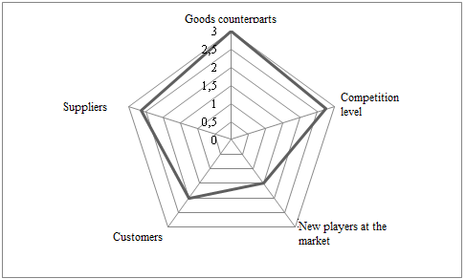
Figure 1 – M.Porter analysis
Secondly, PEST analysis revealed major environmental risks, which nevertheless is compensated by its capabilities. To study the competitive environment the map of strategic groupings was plotted. The map takes into consideration two primary parameters: the reliability of the tour operator and the offered product and presents that analyzed company is not one of the market leaders due to low level of reliability. To sum up, the environment of the tour operator in Russia 2015 year is extremely unfavorable.
In order to understand the company internal environment the author analyzes the company business-model and the web site and, as a result of this analysis, build expanded SWOT, which describes all the steps, tour operator can take. Financial analysis permits to choose the most topical methods and it is presented at the figure 2.
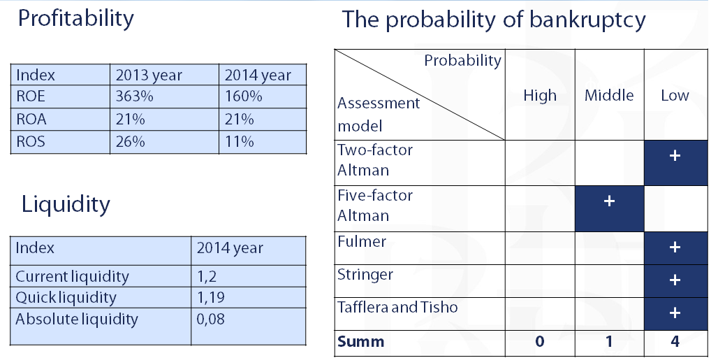
Figure 2 – Financial sustainability of LLC «International Tourism Centers – Moscow»
It, in turn, demonstrates that the company’s margins have increased compared to the previous period, liquidity is normal and the probability of the bankruptcy in 2015 is extremely low. This causes necessity to correct the strategy without changing it radically.
The proposed recommendations involve three areas of company activity. Firstly, this is cost reduction by dint of reducing travel expenses and communication costs and marketing strategy optimization. External environment risks minimizing is associated with the change of the insurance company, with the development of domestic tourism and with the reservation of hotels with the possibility of cancellation. The third area is the improvement the company's image through the service quality monitoring system implementation and the mobile application implementation. The financial efficiency of the recommendations is presented at the table 1.
Tool | Efficiency
Communication costs reducing | 1.000.000 Rub./ year
Business trip expenses reducing | 650.000 Rub. / year
Marketing strategy optimization | 2.000.000 Rub. / year
Mobile application development | 2.300.000 Rub. / 2 years
Table 1 – The efficiency of the elaborated tools
According to forecasts, these steps will increase profit by 180% annually, as well as will improve the quality of tour operator product, that will attract new customers.
The second important result of the research is designing the tour operator sustainability analysis methodology, which includes a comprehensive analysis of external and internal environment (figure 3)
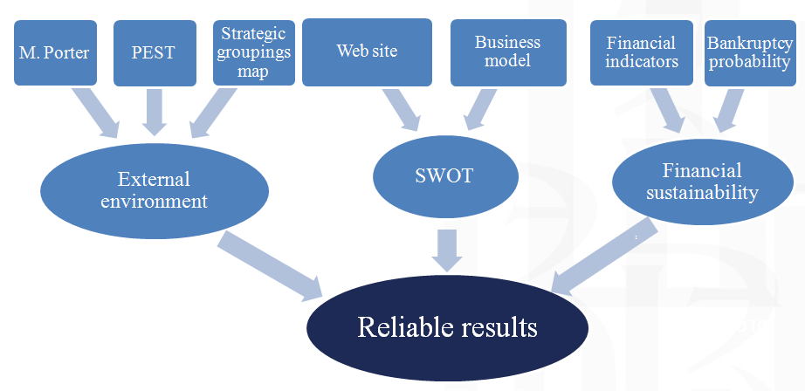
Figure 3 – The logic of tour operator sustainability analysis

Conclusion
The purpose and objectives of this study were fully implemented. The international experience studying and systematization revealed the possibilities and limitations of its use. The current crisis analysis led to the formulation of its causes and what is more important, the methodology of tour operator sustainability analysis was created. The proposed recommendations were not only approved and partially implemented by the management of "International Tourism Center – Moscow", but also of interest to other companies in the industry.

References
- Alegre, J., & Sard, M. (2015). When demand drops and prices rise. Tourist packages in the Balearic Islands during the economic crisis. Tourism Management, 46, 375-385.
- Bronner, F., & de Hoog, R. (2012). Economizing strategies during an economic crisis. Annals of tourism research, 39(2), 1048-1069.
- Khairat, G., & Maher, A. (2012). Integrating sustainability into tour operator business: An innovative approach in sustainable tourism. Tourismos: An International Multidisciplinary Journal of Tourism, 7(1), 213-233.
- Oh, H. (2009). “Revisiting Importance-Performance Analysis.” Tourism Management, 22, 617-627.
- Ovcharov, A.O. (2014). Economic risks and governance of tourism enterprises. Directmedia.
- Papatheodorou, A., Rosselló, J., & Xiao, H. (2010). Global economic crisis and tourism: consequences and perspectives. Journal of Travel Research, 49(1), 39-45.
- Ugarova, G. L., & Semkova, U. V. (2014, October). Anti crisis measures in the tourism industry. In Achievements and Prospects of Economic Sciences: a collection of articles of the International scientific and practical conference.–Ufa: Aeterna (pp. 98-100).
- Zukov, V. A., (2014). The tourism companies strategy development in crisis terms: a collection of articles of the International scientific and practical conference.– Journal of the University (pp. 32-36).

